Part-of-speech Tagging

Source: https://people.ischool.berkeley.edu/~dbamman/nlp20_slides/10_POS.pdf

Parts of speech
- Categories of words defined by distribution of morphological/syntactic contexts
- Morphological distribution: verbs → conjugation
- Syntactic distribution: grammatical sense

POS tagging
- Indicative of pronunciation
- Models
  - Naive Bayes (generative/discriminative)
  - Hidden Markov Model:
    - with 1st order Markov assumption (dependence only on previous tag)
    - with assumption that probability of word depends only on its label

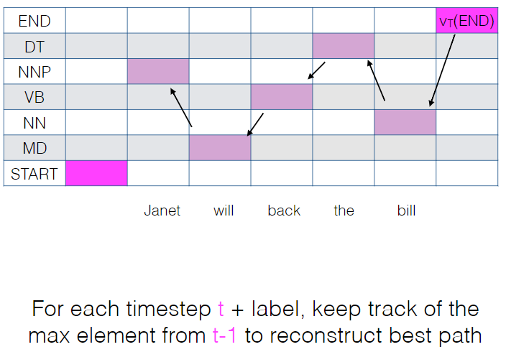
- Decoding
  - Calculate joint probability of all possible paths: N time steps, K labels → paths
  - Viterbi algorithm: discard non-optimal paths up to label L at time T
- Limitation: domain dependent
- Datasets
  - Penn Treebank
  - Universal Dependencies
  - Twitter POS

